Ideation Phase
Define the Problem Statements
Date | 04 September 2026
Student Name | Pulibanti Tejavani
Project Name | Metro Ticket Generating System
Maximum Marks

Customer Problem Statement

Problem Statement(PS) | I am (Customer) | I’m trying to | But | Because | Which makes me feel
PS-1 | A metro passenger | Book a metro ticket with correct journey details | Manual ticket booking can require multiple inputs and may lead to incorrect selections | Station, destination, journey type, and passenger details need to be entered correctly | Uncertain whether the ticket details and fare are correct
PS-2 | A metro passenger | Know the fare before submitting the ticket | Fare calculation can be inconvenient when it is done manually | Fare depends on the selected route, journey type, and number of passengers | Concerned about entering or paying the wrong amount
PS-3 | A metro passenger | Receive a digital ticket after booking | A normal confirmation does not provide a convenient scannable ticket | A digital QR representation is needed for quick verification at the station | Inconvenienced when accessing or validating the ticket
PS-4 | A metro passenger | Complete the booking through a simple portal | Too many unnecessary fields or unclear field behavior can make the form difficult to use | Fields should dynamically respond to the user's selections | Confused about what information needs to be entered
PS-5 | A metro service administrator | Maintain reliable ticket and passenger information | Incorrect or incomplete submissions can affect stored records | Mandatory fields, validation, and controlled access are required | Concerned about data accuracy and system reliability

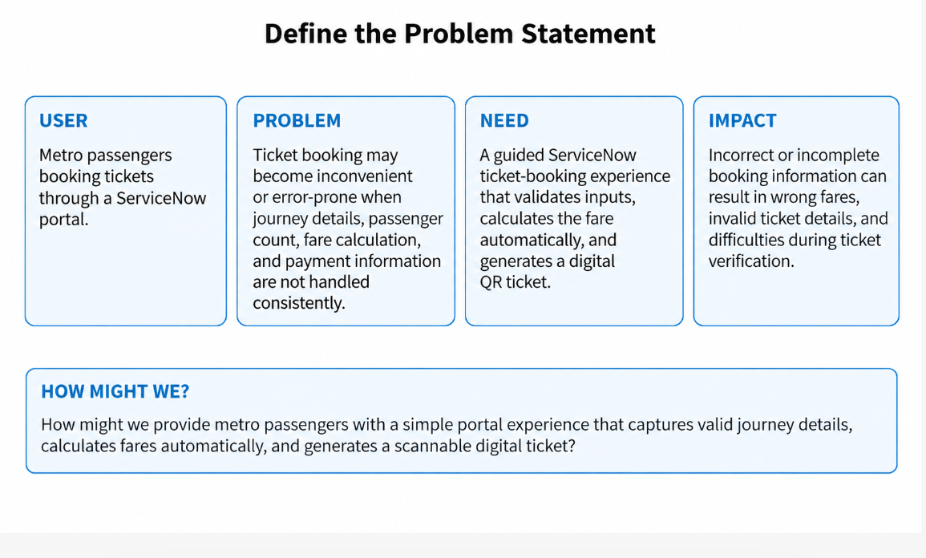

Figure 1: Problem-definition canvas for the Metro Ticket Generating System project.

